FILE HISTORY
1639B06 John Bramley of Egham TS draft SG.docx (25/10/2021)
1639B06 John Bramley of Egham TS draft Ancestry CHECKED SG.docx (07/08/2023)

1639B6/1

In the name of god Amen I John Bramley
of the wicke in the parrishe of Egham in the Countie
of Surrey being in perfecte health & strenth
doe make my last will & testamente this 29th
daie of Januarie in the yeere of o[ur] Lord
1637 as followeth
Inprimis
I giue & bequeath vnto my eldeste sone John Bramley
my house at Stroode now in the occupa[t]c[i]on of Nicholas
Towne w[i]th foure acres of land ioyneing to the common
feild called hurst in the p[ar]ishe of Egham now in the
occupa[t]c[i]on of Henerie Chaundler, w[i]th the appurtenaun-
ces vnto them belonging.
It[em] I giue & bequeath vnto my sone Thomas Brambley
my house at the wicke now in the occupa[t]c[i]on of Richard
Harris w[i]th the appurtnaunces there vnto belonging, and
my close at the Swull¹ now in my owne occupa[t]c[i]on,
It[em] I giue & bequeath vnto my sone William bramley
my house alsoe at the wicke now in the occupa[t]c[i]on of
Ralphe Reade & one halfe acre of land in Egham
feild now in my owne occupa[t]c[i]on w[i]th the appurtenaun-
-ces vnto them belonging.
It[em] I giue & bequeath vnto my daughter Elizabeth
thirtie powndes of lawfull Englishe money to bee paide
her three months after the death of her mother
Bassabee Bramley, ^excepte her mother marrie againe
& then my minde & will is t[ha]t shee should be p[ai]de it w[i]thin
three months after her saide marriage.^
It[em] last of all I make my lovinge wife Bassabee
my full & whole Executrixe of all the remainder
of my Estate goodes & Chattells w[ha]tsoever, to enioye
them for her owne vse duringe her widdowe-
-hood, and ^the^ porc[i]ons a boue giuen & bequeathed to
my foure Children ^for her owne vse during her widdowehood^ but in case shee should bee
married againe, then my will is that there p[or]c[i]ons
should bee paide & deliuered them w[i]thin three months
after her marriage & soe I appoint her to paie
my debts & funerall Charges. In witnesse
whereof I haue heere vnto sett my hand & seale
the 29th daie of Januarie in the yeere of our
Lord 1637 as aboue saide Etc John Bramley

Signed sealed & declared in the p[re]sents
of Anne May & John May
Sara W[….]

Recto
[Latin probate 30^{to} May 1639]
…..Richard Mason…..

1639B6/2
A true & perfecte inventorie of all
the goods & Chattells of John Bramley
of the Wicke in the p[ar]ishe of Egham in the
Countie of Surrey yeoman taken &
appraysed by ^John May^ Jeames Birch & William
Wickes the 16th daye of May 1639

In the hall
Inprimis
one old Court Cabberd a table } xiijs iiijd
& a forme w[i]th other lumber }

It[em] two flitches & a halfe of bacon xs

In the Kitchine
two Iron potts two kettells a } xijs
warmeing pan & skillett & a }
brasse Candlesticke }

It[em] a Cherne, milke boles & other } vs
lumber there }

It[em] all his laboring tooles vs vjd

It[em] a pair of tongs, ^a^ fire showell } ijs
one andiron w[i]th two hookes }
in <the> his Bedchamber
It[em] an old bedstead w[i]th a feather } xxijs
bed a boulster w[i]th a rugg & two }
blanketts }

It[em] his wearing apparel xls

It[em] 8 paire of sheetes ^6 napkins^ } xls
& two table clothes }

It[em] money by him in the house iiijli

It[em] some small pewter vijs

It[em] a Chest & other lumber vjs

It[em] 23 pound of wolline yarne vjs

It[em] a quarter of Rie } xxs
w[i]th tubbs & a fan }

It[em] two old flocke bedds & boulsters } xs
w[i]th some old bedclothes & two }
old bedsteads }

in the barne & yarde
It[em] a dungcart & a heay } xxs
cart & one paire of wheeles }

It[em] a yoke a paire of Strapps a } vjs
paire of Cart ropes & some }
old carte harnesse }

It[em] halfe a loade of heay vjs viijd

It[em] an old frame of a barne } xxs
w[i]th other old timber }

It[em] the poultrie & one pigge viijss

It[em] two meares a colte & a nage iijli

It[em] one yoke of oxen vjli

It[em] 6 Cowes xijli & 3 two yare } xviijli
ling bullokes 3li one three yare }
ling bulloke xxxs & 3 calues xxxs }

It[em] 30 sheepe & 3 lambes vli xs

It[em] 4 hiue of baes xvjs

It[em] 3 acres of barley ls

It[em] halfe an acre of wheate xs

It[em] 3 acres of rie ls

It[em] <two acres of moweing> John May
<29li 16s>
<28 00s>
----------
<57 16>

James Birch
William Wickes

NOTES

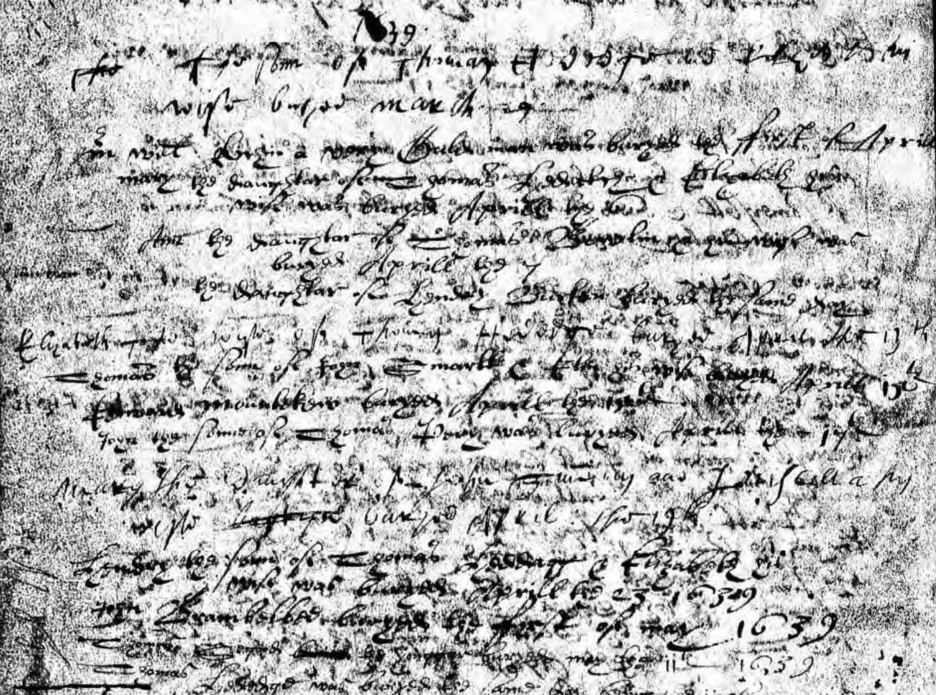

Parish register entry stating "John Brambelbee buryed the First of may 1639"

¹ Swull lane and close - 1650 Parliamentary Surveys (Public Record Office) Survey of English Place-Names

