FILE HISTORY
1637B48 John Wheatley of Chertsey TS draft SG.docx (18/01/2022)
1637B48 John Wheatley of Chertsey TS draft Ancestry CHECKED SG.docx (04/08/2023)

1637B48/1
In the name of god Amen, The Twelfe day of June Anno d[omi]ni 1632 I John Wheatly <of>
the elder of the p[ar]ish of Chertsey in the County of Surr[ey] yeoman being sick in bodie
but whole and sound in mind & memory (god I giue him thanks) do make & declare this my
Testament and last will in manner and forme following viz[t] First & principally I doe
bequeath my soule into the handes & p[ro]tection of god my Creator and maker, and to Jesus
Christ my only mediator and redeemer by whose death & Merits & righteousnes I
do hope to haue free pardon & forgiunes of all my sins & offences And my bodie I do
comit to the earth to be buried in the Church yard
Allso I do giue & bequeath vnto my Loving wife my best Bed with all things thervnto
belonging together with 4 paire of my best sheets
Allso I doe giue vnto my son in lawe John Warner Twelue pence
Allso I do giue vnto my son in law John Wise of Winsom¹ Twelue pence
Allso I doe bequeath vnto my eldest son John Wheatly All & singuler the goods w[hi]ch
my said son John now hath in his custodie & possession
Allso I do giue vnto my daughter Margeret Twelue pence
Allso I do giue vnto my daughter Elizabeth Twelue pence
Allso I do giue vnto my daughter Katherin Twelue pence
Allso I do giue & bequeath vnto all & eche of my grand Children Twelue pence a peece
Allso I do giue vnto my grand Childs Child that is to say John Roke the younger of Woking
in the County aboue said Twenty shillings of lawfull money to be paid vnto him at the age
of Sixe years.

The rest of my goods <I> (my debtes & Legacies being paid) I doe giue vnto myne executor
whom I doe ordaine and appoint to be my youngest son Richard Wheatly.
And for the overseers of this my will I doe desire & appoint to be Henry Mellist the elder
of Horsell & my son in Law John Roke of Horsell giuing vnto them for their paines
Five shillings a peece.

In witnesse wherof I the said John Wheatly to this my Testament & last will I
haue set my hand and Seale, Giuen the day & yeare first above written.

The marke of the said
John [mark] Wheatly

Read Signed Sealed and delivered in the pr[e]sence of theis
whose names are hervnder expressed and written
The marke of
John [mark] Smither
The marke of
Richard [mark] Stilles

[Latin probate 25^{to} May 1637 to Richard Wheatly Executor]
…..yeoman

1637B48/2 p1

An Inventory of the goodes and Chateles
of John Wheatley ^the elder^ late of Woodam in
the parishe of Chertsey decesed in
the County of Surrey Taken the xxj
day of marche 1636 as followeth

Imprimis
his wearing Apparell and } iijli
mony in his purse }

in the chamb[er] over th halle
Item i standing bedsteed } xs
i blankett i Coverlid }
i Joyn chest }

Item xiiij payr of sheetes iiij } iiijli
tabl clothes viij tabl napkins }
i payr of pillow bears }

in the chamb[er] over the parler
Item ij bedsteades i fether bed } xlviijs
i flock bed ij bowsters ij pillows }
ij Coverlides iiij blankettes }

Item i pres iiij chestes xvs

In the parlor
Item i bedstead i flock bed ij } iijli
bowsters ij pilowes ij blankettes }
i Coverlid i Cort Cubberd I }
littill table i Joyn Cheyer }

in the hall
Item i tabl i forme i bench w[i]th } xxs
a backe to it i Cobberd ij ould }
Chayers }

in the Chichen
Item in bras xxiiijs

Item in pewter xv peeces xxxs

Item spittes and driping pans } vjs viijd
i payr of Iorn ondiorns }

Item in tubbes and othe lomber xs

In the buttery
Item i saulting trowe i bulting } ls
wiche i kneding trow vj veselles }
to put in drink and other lomber }

in the chamb over the chichin
Item ould lomber } xiijs iiijd
and i woomans sadle }
in the chamb <of> over the buttery
Item in mavlt xlvs

In the barne
Item xl Busheles of corne vli vjs viijd
french wheat xiijs iiijd

Anthony Bennett
Richard Roake
John [mark] Smether

1637B48/2 p2

In the fild
Item in dry sheepe lxx xvijli xs
Item xxx yewes and lames xli
Item v kine xij bullockes xxxli
Item ij horses vli
Item vj calfes iiijli
Item cartes and plowes xxxs
Item corn on the grownd viijli
Item iij stalles of bees xvs
Item vj small horses xlviijs
Item in poultery vs

Som is in all Cviijli ixs

Anthony Bennett
Richard Roake
John [mark] Smether

NOTES
John Wheatley was buried on 10 March 1636
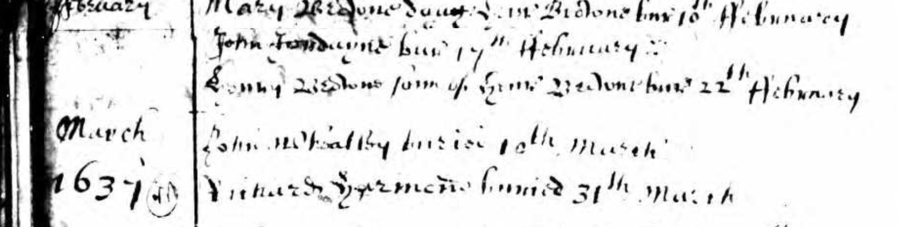
https://www.ancestry.co.uk/search/collections/4790
Surrey, England, Church of England Baptisms, Marriages and Burials, 1538-1812

¹Winsom - thought to be an abbreviation of Windlesham as Wise is a name that occurs there.

