Susannah Headige of Egham 1637B23

SG transcript Ancestry CHECKED 25/05/23

1637B23/1

In the name of god Amen the xxvth day of Aprill 1637 I
Susan Headidg of the p[ar]ish of Egha[m] in the County of Surrey
widdow benig sick of body but of p[er]fect Memory praised be god
do make this my last will & testam[en]t in mann[er] and forme following -
first I bequeath my soule into the handes of god my sauio[ur] and
redeem[er] and my body to be buryed in decent mann[er] as becometh
a Christian. Ite[m] I giue and bequeath vnto Susan my daughter
my table in the hall & six Joyned stooles, also my bedstead and
bed and all things thervnto belongnig standing in the p[ar]lo[ur] -
Also a brass pott a skillett & a skimm[er] also <my oulder> two Chestes
standing in the p[ar]lo[ur] & also my bigger whitfaced bullock
Ite[m] I giue & bequeath vnto Jane my daughter the loose wainscott
in an old house <to> Ite[m] all other my goodes & Chattailes whatsoeu[er]
my dettes & fun[er]all expences discharged I giue vnto my said two
daughters to be equally devided betwixt them. And my will
and desire is that yf will[ia]m banister ^my sonn in law^ shall dwell and Continue in
the house wher I now dwell that then he shall alow vnto my
daughter Susan the vpp[er] chamber in the said ^house^ ther to be and keep
her goodes so long as she shall continue vnmarried
And I doe ordaine and appoint John Fletcher my brother in Law
<my> ^sole^ Executo[r] of this my last will & testam[en]t
Ite[m] all other wills giftes legacies and bequests by me hertofore
willed giuen & bequeathed I doe by those p[re]sentes make vtterly
voyd & of none effect & do acknowledg this to be my last will &
testam[en]t In witnes wherof I haue hearvnto sett my hand &
Seale the day and year first aboue written
Sealled & declared
in the p[re]sence of vs
John Standen
willyam gibson
the [mark] m[ar]k of
Susan Headidg
[Latin probate xxvth may 1637 to John Fletcher yeoman]

FRONT OF WILL
25 May 1637 ......
Giuelmo Kaye Rectore
...................... in Guildeford

1637
Susanne Headige
... Egham ........

1637B23/2
An Inventorie of all the goodes and Chattailes of Susan
Headidg widdow late ^of^ the p[ar]ish of Egham in the County of Surrey
deceased taken the second day of May anno domine 1637 praised
by John Standen Will[ia]m Gibson Will[ia]m Wilcox & Peter Aslett

Inprimis her money in her purse & wearing app[ar]ell xxs

In the hall
Item A table and six Joyned stooles xiijs iiijd

Item A Cupboord an old Counter a litle chaire with } vjs
ij stooles and benches }

Item A paire of andIrons pot hangers fyre shouel & tongues } iiijs
& a pare of Bellowes }
Pewter
Item six dishes iiij sacers a pinte pott a bowle a salt } xiijs
a candlestick & six spoones }

In the Kitchin
Item of Brasse one little pott a skillet a skimm[er] viijs
Item two Cettles two little skilettes & a Morter vjs viijd

Item A frying pan a gridIron a speet, pothangers } vjs viijd
with a woolen wheele & other earthen vessell & wooden dishes }

In the p[ar]lo[u]r
Item A bedstead a flockbed ij fether boulsters a little } xls
pillow a straw bed a blankett & a Rugg & two chestes }

Item one other chest a chare table an old cupboord a little } vjs
hanging cupboord & one box with c[er]tain painted clothes }

In the buttry
Item two drinktubbs a kneading Couer a cherme a bowle } viijs
a search a little tub ^w[i]th other milking vessels^ }
with a poudering trough & shelues }

In the upp[er] chamber
Item an old Flockbed with an old half bedstead a chest } xs
a linnen wheele & other lumbery an old cou[er]lett }

Linnen
Item two pare & one sheet a table cloth & three napkins vjs
Item three acres of Rye vpon the ground vjli
Item two acres of berly vpon the grownd iij li
Item a certaine p[ar]cell of oates xs
Item an old nag with a mare & a colte iij li
Item one whitefaced heaffer xls
Item one Cow & two yearling bullockes iiij li
Item fower ewes & lambes & iiij other sheep xls
Item one shoot on yong hogg vjs viijd
Item three henns w[i]th some chickings iijs

Item an old cart with ploughes harrowes harnes } xxs
and other husbandry Implem[en]tes }

Item certaine old wainskott in an old house ijs
Item certain dunge js
Summa xxix li ixs iiijd
totalis est

Oweing by the testatrix vnto her landlord for } iiij li
rent due at o[ur] lady day last }

of other dettes to seu[er]all p[er]sons xvj li xs
disbursed for fun[er]all] expenses xixs
to the p[ar]son for tythes due at o[ur] Lady day last viijs ixd
The somme hereof xxj li xvijs ixd

Oweing to the Testatrix xxvs vjd

John Standen }
William Gibson }
the m[ar]ke of } praisers
William Wilcox }
the m[ar]ke of }
Peter Aslett }

Notes

Susan Headidge was buryed on 1 May 1637 at St John's Church, Egham, Surrey.
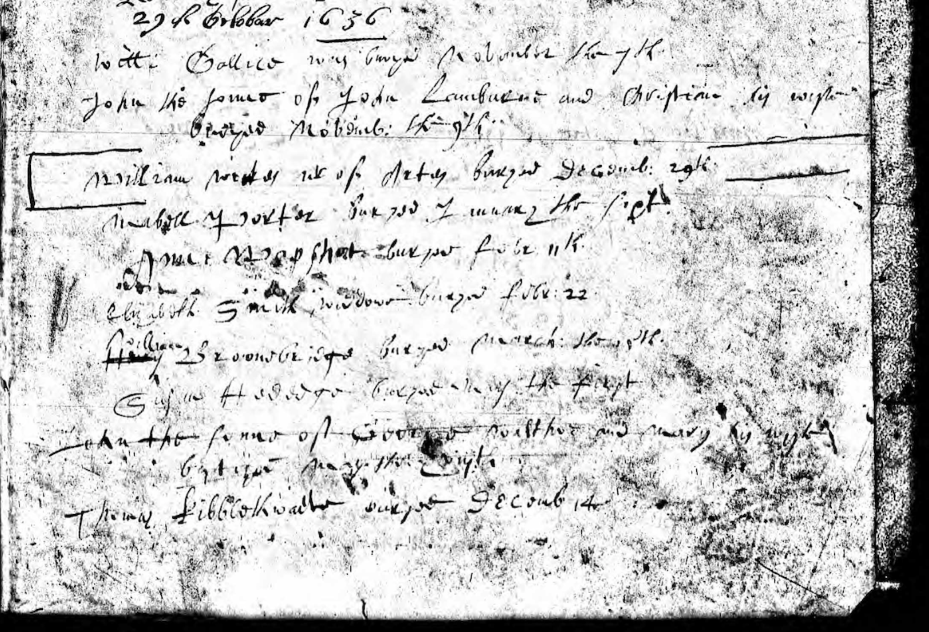
Ancestry - Surrey, England, Church of England Baptisms, Marriages and Burials 1538-1812

