1608B45 John Loyck of Elstead TS First draft ALM

In the name of God amen the xxiij day of January and in
the year of our lord god 1608 and in the Raygne of our Soveraygne
Lord James by the grace god kynge of England France
and Iyreland the sixthe of Scotland the one and fortye defender of
the fayth and of the Church of England have in earth next curedyably
under god of his goodnes suprime God and govenor & I John loycck of
the p[ar]ish of Elsted in the countye of Surry husbandmen beinge agtned
and syck in body but is havin good knowledg and parficte memory
thanckes be unto almghty god therfor god I doe ordayne and macke
to be my very last wylle and testyment in maner and forme followinge:
Fyrst I will and bequeue my soull to almighty god and to all the holy
company of heaven and my bodye to be buryed in the yard of my
p[ar]ish church accordynge to the coystome & maner of all faythfull
and Cristyan pepelle: also I will and geve to the pore of my p[is]sh
Sixe pence yeure in monye. Also I will give to my sonne John one cowe
and fyve shepe: and tywentye shellynges in mony which mony is in the
handes of willim Bromhame: Also I will and give to my doster
margeret one cowe and four shepe. also I will and give doster
Jane Barlo fyve shellynges in monye; also I well and give to her
cheldoren fyve shillings in moneye to be davyded equally amongest them
also I will and give to my goddoster margery hart fourre piuce in mony:
aslo I will that my sone John and my doster mageret shall have the
one half of all hauseholde stouf and if my wife should hapen to
marye agayne it to be delyuered at the day of her mariege or else not
till the deces: all the Resedeu of my goodes and catell be
Bequeuen and wguen I will and geve to Alce my wyfe whome I mack
my wholl excecuter to tack my drues and to paye my detes: and I
will that John Smelling adn Rychard Borkeham shalle be
overseres of this my will & testement that it maye be the let
don and fulfelled and they have for them Labor and paynes
tacking feytene pence apece
The mark of john loyck
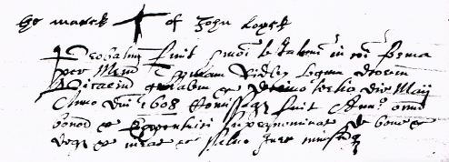
1608
The inventory of the Goodes of Johm Loycke late desesed
Item he has of mony in his parse xiiij d
Item his aparell covandth vs
Item for thre kyne iiij li
Item to bollockes xx s
Item on heffer and one bollocke xxs
Item for twenty shepe iij li
Item for one acker of Rye xvj s
Item for to ackers of otes xi sj s
Item for his pewter ijs vjd
Item for his brase iij s
Item for his beding vs
Item for his bedstedell xx d
Item for thre cofers v s
Item for wooden vesell ij s vj d
Item for thre shetes vj s
Item for to bosheles of rye vj s viij d
Item for to bosheles of otes x iiij d
Sumdis xij li vj s ij d
The marke of John Smellynge
The marke of Rochard Bockehame
Rychard Artnell

