Puttenham Terrier Transcription Project

The contents of the terrier are written in handwriting that should be reasonably legible to modern eyes. If you would like to learn a bit more about palaeography before you get started, we suggest the following Introduction to Palaeography tutorials and tips as very useful starting points:
- The National Archives Palaeography online tutorial
- The US National Archives Transcription Tips (a more succinct page)

The following guidelines outline how participants should enter the contents of the terrier in the tables. Please also refer to the examples on the following pages.
The transcriptions are based on the following conventions:

1. The pages of the terrier are divided up into rows and columns, so what is transcribed should replicate the locations of the words as far as possible.

2. The pages of the terrier aren’t numbered. Where the list of names goes over onto a new page, leave a blank row and enter (NEW PAGE) in the far left-hand column.

3. There are a significant number of later additions and annotations to the original text. Some are dated later than 1765 and are easy to recognise; others are more subtle. Such later text must also be transcribed but between square brackets (i.e. [ and ]) to distinguish it from the original text.

4. Additions to the text written in pen should be transcribed in between square brackets in normal font, i.e. [example].

5. Additions to the text written in pencil should be transcribed in between square brackets in italic font, i.e. [example].

6. There are a number of abbreviated words/names where the final letter is superscript, i.e. written smaller above a dot of dash. To keep things simple, render them in regular-sized font one after the other, e.g. Thos. (for Thomas)

7. Where you feel it is not possible to represent what is in the text, mark it with a number, beginning with 1, between parentheses in the nearest suitable place in the text. Near the foot of the table, and placed on the appropriate side of the table for whether the feature in the text is on the “facing" or “main" page, enter the same parenthetical number again in the far left-hand column, and in the adjoining cell in the same row an explanation of what the particular feature of the text is.

8. An optional ‘notes’ section at the bottom of the transcription sheet allows participants to think about and make suggestions of the meanings of the names they transcribe and possible etymologies. The new Guide to Researching the Landscape of Surrey in the Middle Ages is a useful overview of resources available, particularly the section on place-names, including The Key to English Place-Names which provides currently-accepted etymologies of major place-names, i.e. those of parishes and other significant places.
The following serves as a useful overview and guide to placenames which are specific to the Puttenham project:
The first rule of studying historic name spellings from an etymological perspective is to collect as many instances of a name as possible before attempting any detailed analysis of its composition and meaning. In the case of the 1765 Puttenham parish terrier, more than half of the field-names it contains represent the earliest known attestations of those names. While it does not necessarily follow that because they date from nearer to when the names were coined than later spellings they are “purer” and more easily-etymologised than later spellings, for the purposes of this exercise the terrier does offer a useful and controlled practice ground for etymological work.

A good number of the name elements found in the terrier have the same significance as their Present-Day English equivalents (e.g. Barn, Kiln; Hill, Pond; Stile, Path; Upper, Little). Others are not so readily recognisable and interpreted, and the terrier includes a few peculiarities and even a couple of genuine obscurities!

Fortunately, many of the names in the middle ground between the etymologically obvious and obscure contain the same elements. The following list is a “Top 20” of elements that are to be found in multiple names contained in the terrier, and so can help to identify the derivations and possible original meanings of all or parts of them. They are either dialect terms no longer in use or, more trickily, familiar-looking words with different meanings to what they hold today. All can be found in field-names in other Surrey parishes, and most (if not all) have recorded precedents earlier than those in the 1765 terrier.

Breach: from Old English (OE) brēc, Middle English (ME) brēch(e) ‘newly-broken ground’
Butts: most likely ME butte ‘irregularly-shaped remnants of an open field’
Close: ME clōs ‘small, enclosed piece of land’
Copse: ME copis ‘(land by/containing) a thicket’
Croft: from OE, ME croft ‘small enclosure’
Dean: from OE denu, ‘valley’
Down: from OE dūn, ME doun(e) ‘low hill; upland pasture’
Furlong: from OE furlang, ME furlong ‘division of/enclosure within an open field’
Furze: from OE fyrs, ME firs(e) ‘land on which furze or gorse grows’
Grove: from OE grāf, ME grōve ‘(land by or formerly) a grove, copse, or plantation of trees’
Hatch: from OE hæcc, ME hacche ‘a hatch-gate’
Hide: from OE hīd, ME hīde ‘land sufficient to support a family’
Hook: from OE hōc, ME hōk ‘angle, corner or bend of land’
Horn: from OE, ME horn ‘horn-shaped piece of land’
Land(s): from OE, ME land, either ‘plot of land’ or ‘strip(s) in an open field’
Mead: from OE mǣd, ME mēd ‘meadow; grassland’
Moor: from OE, ME mōr ‘unproductive waste land, usually wet’
Piece: ME pece ‘portion or fragment of land’
Plat: most likely ME plat ‘flat piece of land’
Vere: from OE furh ‘piece of arable land; furrow’ (here used for a subdivision of an open field)

Translations are taken or adapted from P. Cavill, A New Dictionary of English Field-Names (Nottingham: English Place-Name Society, 2018).

Puttenham Terrier Transcription Project

Example entries

Parcel numbers 1 to 10

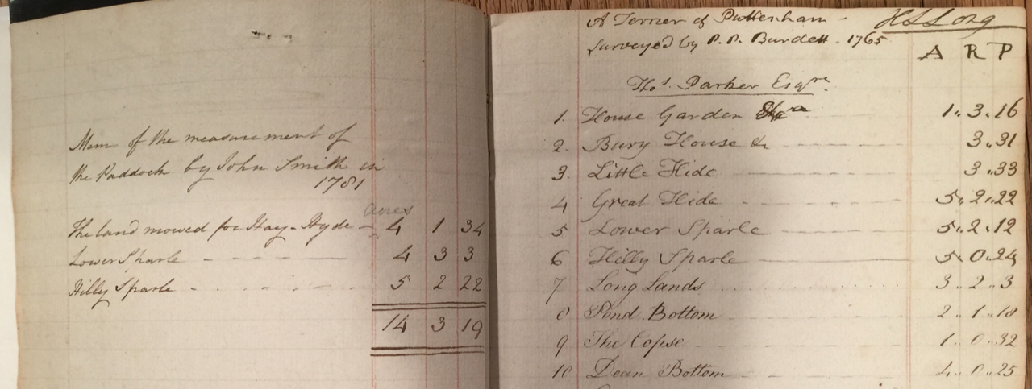
 | Facing page parcel name | Facing page Acre - Rod - Perch | Parcel number | Parcel name | Acre - Rod - Perch
 |  |  |  | A Terrier of Puttenham  Surveyed by P. P. Burdett . 1765 | [HLLong]
 |  |  |  | Thos. Parker Esqre.
 | Example  [The land mowed for Hay. Hyde _] | [Acres]  [4 1 34] | 5 | Lower Sparle | 5,,2,,12
 | [Mem. of the measurement of] |  | 2 | Bury House &c | 3,,31
 | [the Paddock by John Smith in] |  | 3 | Little Hide | 3,,33
 | [1781] |  | 4 | Great Hide | 5,,2,,22
 | [The land mowed for Hay. Hyde _] | [Acres]  [4 1 34] | 5 | Lower Sparle | 5,,2,,12
 | [Lower Sparle _ _ _ _ _] | [4 3 3] | 6 | Hilly Sparle | 5.0.24
 | [Hilly Sparle _ _ _ _ _ _ _] | [5 2 22] | 7 | Long Lands | 3.2.3
 |  | [14 3 19] | 8 | Pond Bottom | 2.1.18
 |  |  | 9 | The Copse | 1.0.32
 |  |  | 10 | Dean Bottom | 4.0.25

Example entries

Parcel numbers 143 to 150

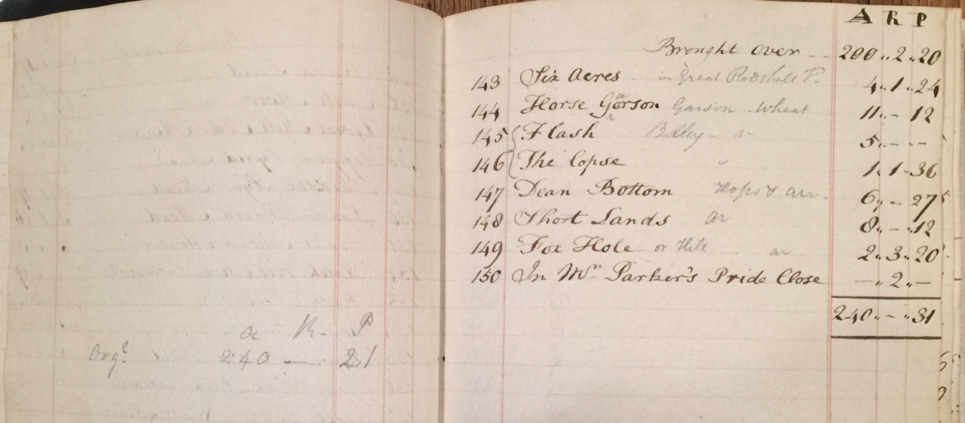

Facing page | Facing page parcel name | Facing page Acre - Rod - Perch | Parcel number | Parcel name | Acre - Rod - Perch
 |  |  |  | Brought over_ _ | 200,,2,,20
 |  |  | 143 | Six Acres [in Great Rodsall Fd.] | 4,,1,,24
 |  |  | 144 | Horse Gorson [Garson . Wheat] | 11,,-,,12
 |  |  | 145 | Flash [Barley _ ar] | 5,,-,,-
 |  |  | 146 | The Copse [“] | 1,,1,,36
 |  |  | 147 | Dean Bottom [Hops & ara] | 6,,-,,27
 |  |  | 148 | Short Lands [Ar] | 8,,-,,12
 |  |  | 149 | Fox Hole [or Hill Ar] | 2,,3,,20
 |  |  | 150 | In Mr. Parker’s Pride Close | -,,2,,-
 |  |  |  |  | 240,,-,,31
 | [A R | P]
 | [Orgl. 240 _ | 21]

