1619B19 Arthur Davie of East Clandon TS draft MK01 CF CHECKED 12/07/2022 CF checked ANCESTRY 18-01-2024
NB Davy (, Davie (the document), Davey (Ancestry)

In the name of God amen the 30th daie of Januarie 1618. I Arthure Davie of the p[ar]ishe

East Clandon in the Countie of Surr[ey] yeoman beinge in good & p[er]fect health & remembrance thankes be to god

& Consideringe the estate of man to be mortall, doe here ordayne publishe & declare the tenno[r] of this my laste

will & testament in manno[r] & forme followinge (viz),.

Inprimis
First I bequeath my soule to the Almightie god my maker & redeemer, by whose merrittes & deathe I hope to haue

forgiuenes of all my sinnes & by his resurrection to rise againe vnto liffe everlastinge, And my bodie to be

buried in the Churchyeard where I now dwell in EastClandon aforesaid. Item I give & bequeath towardes the

maintaynynge of the Churche Rayles of EastClandon aforesaid, the some of iijs iiijd to be paid by my Executo[r].

Item I gyve & bequeathe vnto Annis Davie my wife the p[ar]lo[r] sev[er]all to herself duringe her naturall life and

no longer, w[i]th beddinge to ly uppon, not to renmove nor give awaie any thinge, but to leave all thinges standinge to my
Executo[r], More I will & bequeath that my said wife shall haue her diett in the house & fyre roome att the Cost & chardges

of my said Executo[r] duringe her naturall life if shee doe like of it, But if it shall happen my said wife to go awaie & not to

like of it & cann mende her diett in any other place, Then my will is That shee shall haue Three poundes a yeare

duringe her naturall lyf to be paid by my Executo[r] quarterly as shee shall haue need of it. Item I give and

bequeathe to my Daughter Dugglesse the wife of Thomas Gosdine of wonershe the some of Twentie Pounds of lawfull

money of England to be paid vnto her w[it]hin one whole yeare next after my discease by my said Executo[r]. Item I give

& bequeathe vnto my daughter Sara Davie the some of Twentie poundes of the like lawfull money of England to be

paid vnto her by my Executo[r] as aforesaid if shee will be ruled by my saide Executo[r] as aforesaid in the bestowinge of her

self in marriage. Item I give & bequeathe vnto younge Arthure Davie the sonne of my sonne Thomas Davie, All

my lease land to be vnto the said younge Arthure Davie the sonne of my said sonne Thomas Davie & the heires of his bodie

lawfullie begotten for ever more. But if it shall happen the said Arthure the sonne of my said sonne Thomas

Davie to dye w[it]hout heires of his bodie lawfullie begotten, Then my will & mynde is that all the aforesaid my lease

land shall remayne & be vnto the next heire male of the said Thomas Davie my sonne, And for want of heires male, vnto the

righte heires of the said Thomas Davie my sonne as my Free guifte for ever more w[it]hout imp[ea]chment of waste. Item I

give & bequeathe vnto Edward Davie the sonne of Thomas Davie my brother Twentie shillinges of like lawfull money of England

to be paid vnto hym by my Executo[r] as aforesaid. Item my will is that the said Arthur Davie the sonne of my said sonne Thomas shall

have the thirty shillinges w[hi]ch his vnckell Robert Grethurst gave hym. to be paid by his Father & Tenn poundes w[hi]ch his Grandfather

gave hym to be paid also by his Father att the daye of his marriage. All the residue of my goodes Cattelles, Chattelles &

ymplementes of houshold stuffe ungiven & bequeathed my funerall dischardged, I give & bequeath vnto the said

Thomas Davie my said sonne, whome I doe make my full & whole Executo[r] of this my last will & testament. I have

Ordeyned for my Overseers to see this my last will p[er]formed, my wellbeloved frendes Steven Crutcher & John <…> ^ Jourdan^

of EastClandon givinge unto eche of them fyve shillinges for their paines takeing & all chardges borne to see this my last

will p[er]forme[d] orderly as aforesaid. In witness wherof to this my p[res]nte last will I have herevnto sett my hand &

seale the daie & yeare first above written. More I will that the said Annis Davie my wife shall have two chestes

The m[ar]ke & seale of me Arthure Davie
Signed sealed and read in the p[rese]nce of
The m[ar]ke of William Scotcher
nichollas Forde Junior
John Longe

[Probate in Latin 14 May 1619 to Thomas Davye]

[CF Comment: Thomas Gosden’s son was baptised in January 1606 at Wonersh church. See Wonersh parish registers,
Inventory 1619B192

A true Inventory of all the goodes & chattell of
Arthur Davye of Eastclandon in Surry deceased
taken may the sixt 1619

Inp[rim]is in his purse vli
It[e]m his apparell xls
It[e]m in the hall a table & acupbord w[i]th other thinges xxs
It[e]m in a Lower chamber by the hall xxxs
It[e]m in an other Lower chamber a bedsted & flock bed xxs
It[e]m two bedsteedes & two cov[er]lettes w[i]th furniture to them & a chest xls
It[e]m six pair of sheetes two table clothes a pare of pyllow beres xxvjs viijd

It[e]m six platters & six peuter dishes two saucers & a doossen & a halfe of } xvjs vjd
Spones three saltes thre candlestickes }

It[e]m a lytle brasse ^two^ posnettes four kettles one spitt a pare of cobyrons } xxxs
a payre of pothangers }

It[e]m a fate a kneding troffe & a bowlting huch a bucking tub w[i]th } xixs
other Lomber }

It[e]m the Bacon & cheese in the house xls
It[e]m the corne & mault in the house & barne iiijli
It[e]m seven acres of wheat & xiij acres of barly in the feild xxli
It[e]m ix acres of Teares & three of oates vijli

It[e]m one horse two coltes three kyne three lytle bullocks } xiijli
two lytle bullocks more }

It[e]m xxv sheepe & sixe Lambes vli
It[e]m four hoges & four piges xls

It[e]m a Long cart & two dung potts w[i]th plowes harrowes & } iijli
harnys & other husbandly ymplementes }

It[e]m the dung in the gate & p[ar]t of a costlett xxxs
It[e]m a cook & fyve hennes iijs

Sum[ma] tot[alis] thre score fourtene poundes sixtene shillinges & twopence

This Inventory was taken the sixt daye of maye By John Jourdenn &
John Tydy & Steven chrocher
th[e] m[ar]ke of John [mark] Jordon
th[e] m[ar]ke [mark] of John Tydye

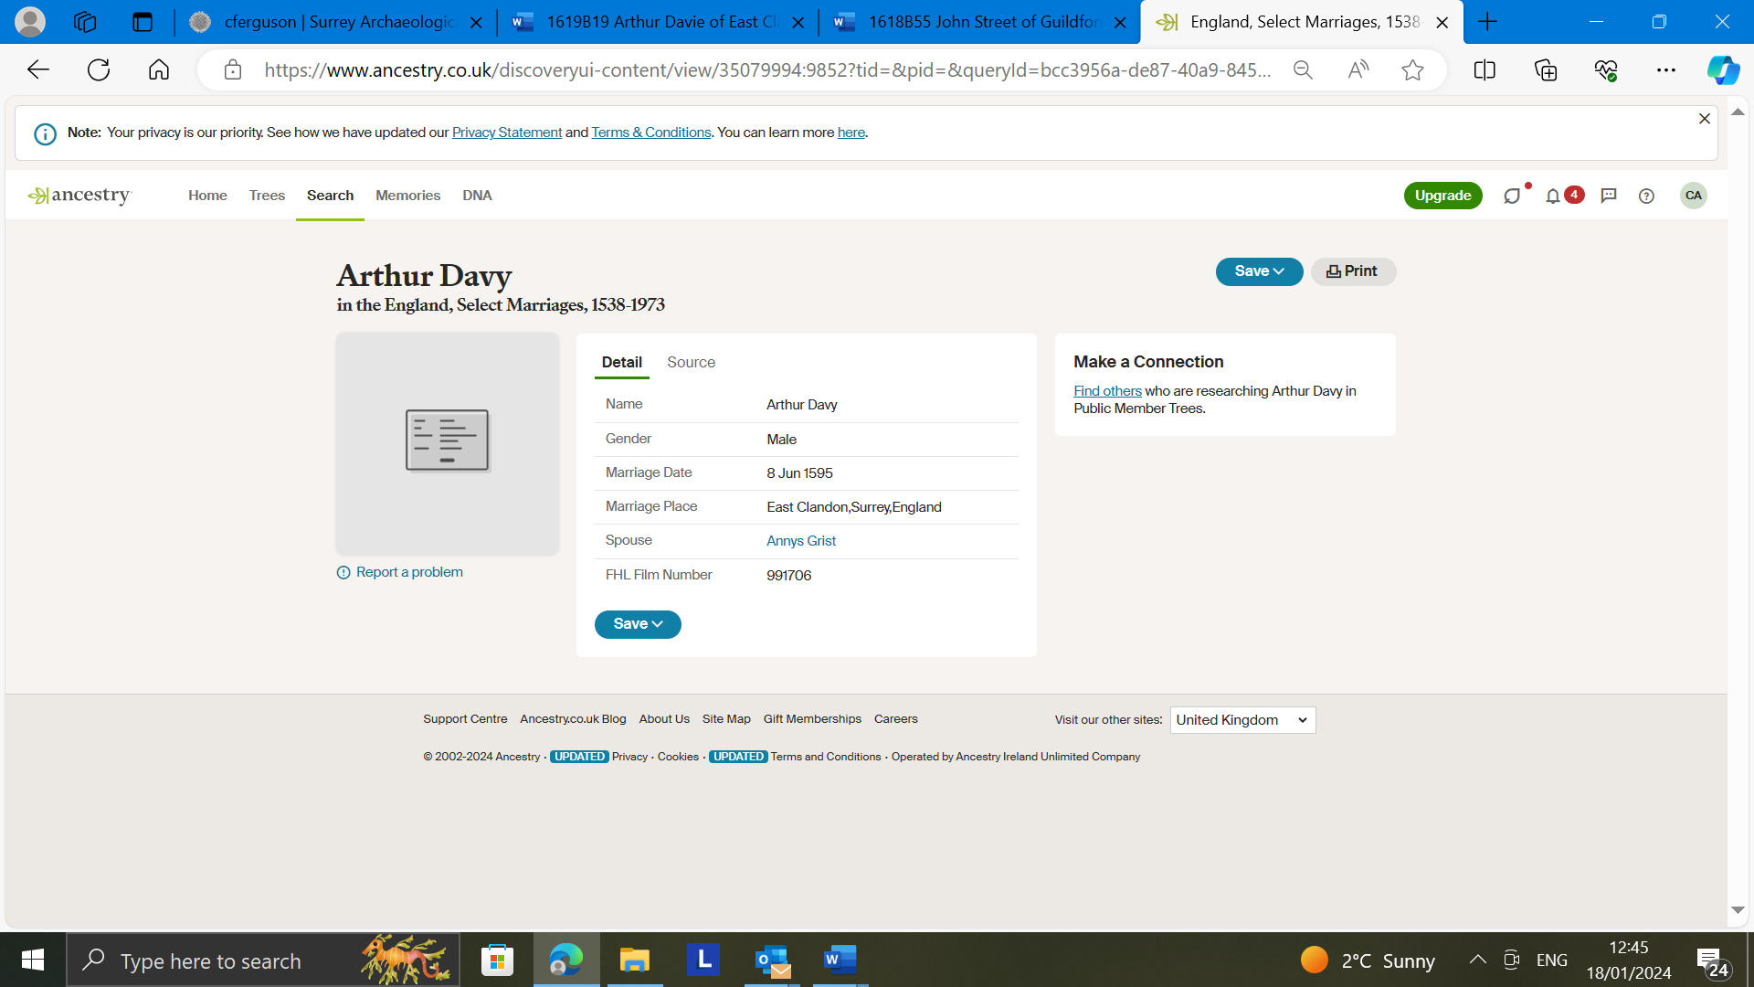

CF COMMENT Could this mean a room, or even a separate part of a room making a parlour? The inventory does not refer to a parlour at all (presumably because its contents had been given away to the widow). TO BE DISCUSSED….
Is this costlet which is an item of armour. But what is it doing in the dung heap – is it because it might be broken, hence ‘part of’?

